The Japanese Attack Pearl Harbor

On the morning of December 7, 1941, the Japanese launched a surprise air attack on the U.S. Naval Base at Pearl Harbor in Hawaii. After just two hours of bombing, more than 2,400 Americans were dead, 21 ships* had either been sunk or damaged, and more than 188 U.S. aircraft destroyed.
The attack at Pearl Harbor so outraged Americans that the U.S. abandoned its policy of isolationism and declared war on Japan the following day -- officially bringing the United States into World War II.
Why Attack?
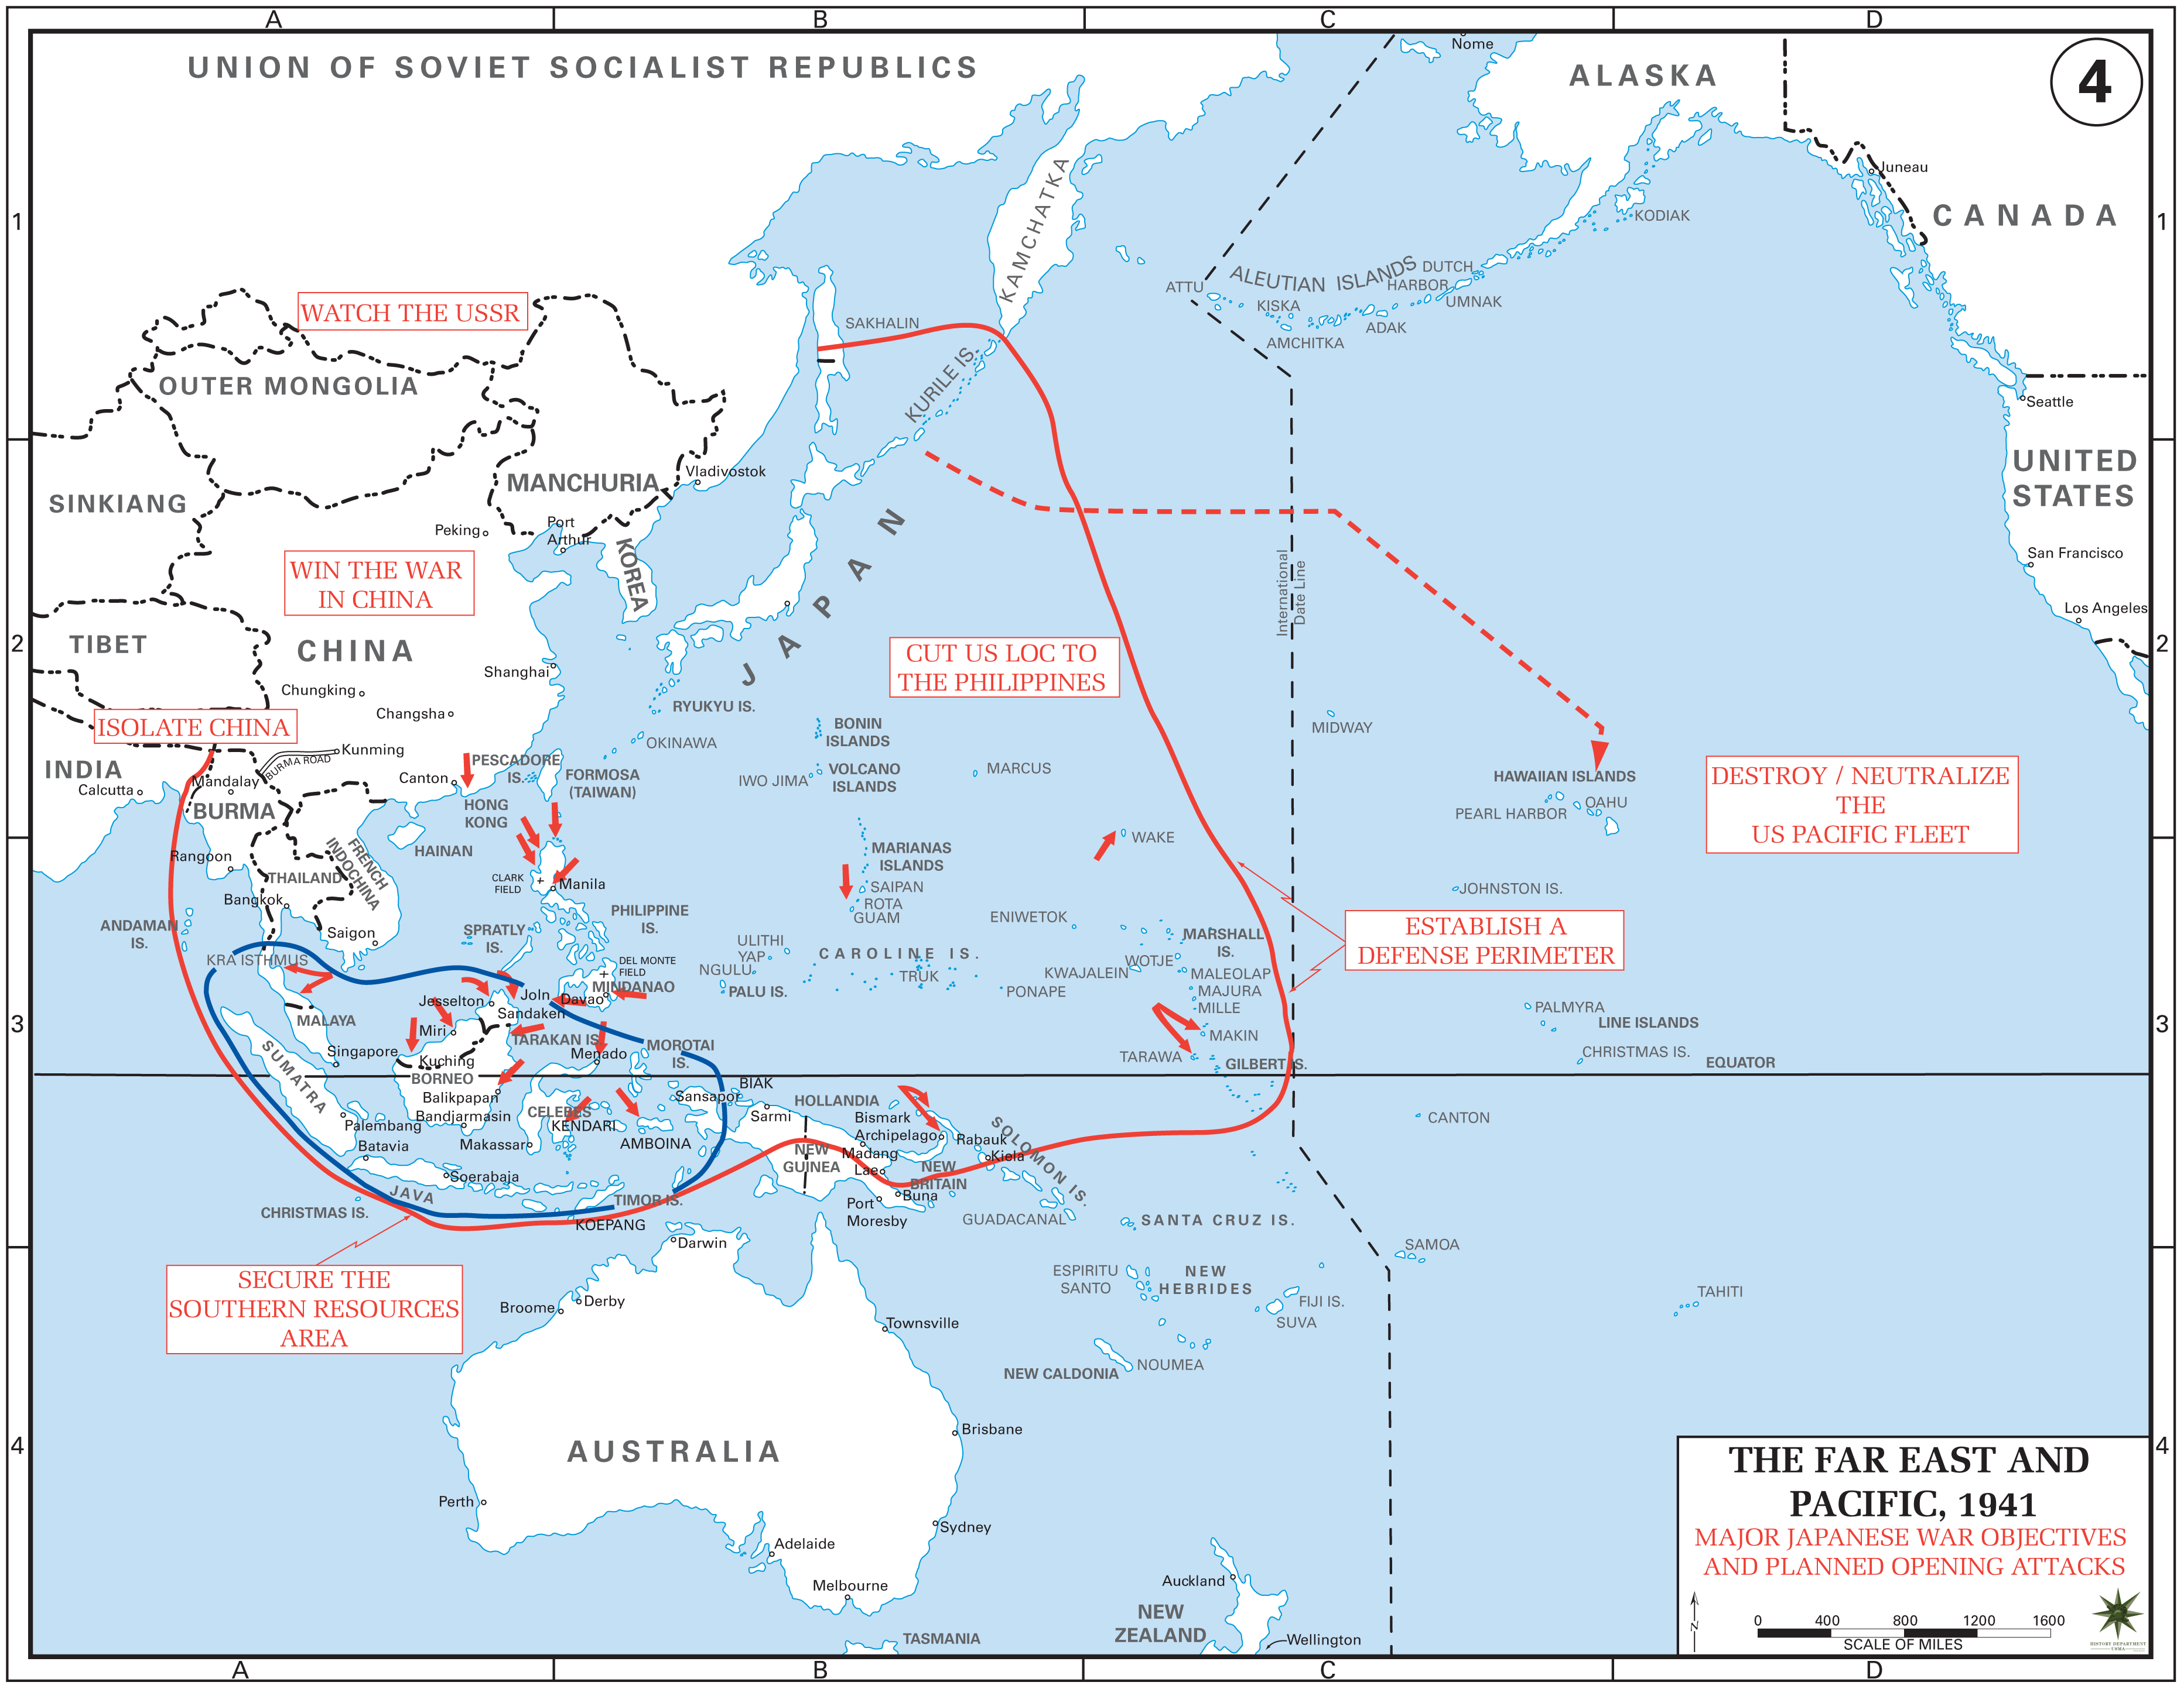
The Japanese were tired of negotiations with the United States. They wanted to continue their expansion within Asia but the United States had placed an extremely restrictive oil and steel embargo (ban, restriction) on Japan in the hopes of curbing Japan's aggression. Japan had been expanding throughout Asia in order to gain natural resources (eg. steel, oil, rubber) so it could maintain a large, powerful empire in the Pacific. This plan brought them into direct conflict with the U.S., who held territory (eg. the Philippines) and had extensive economic interests in the region. Negotiations to solve their differences hadn't been going well. By the summer of 1941, although both governments continued to negotiate their differences, Japan had already decided on war.
The Japanese decided to launch a surprise attack against the United States in an attempt to destroy the United States' naval power even before an official announcement of war was given. The attack on Pearl Harbor was part of a grand strategy of conquest in the western Pacific. After this surprise attack, Japanese military officials calculated, American power would recover – but not before Japan had built a defensive rim of air and naval bases around the central and south-western Pacific. To break through this, the Americans would have to wage a long and exhausting campaign. Japan thought that public opinion would eventually force Franklin D. Roosevelt to negotiate a peace – leaving Japan with its gains from the British and Dutch empires.
The Japanese Prepare for Attack
The Japanese practiced and prepared carefully for their attack on Pearl Harbor. They knew their plan was extremely risky. The probability of success depended heavily on complete surprise.
On November 26, 1941, the Japanese attack force began its 3,000-mile journey across the Pacific Ocean. Sneaking six aircraft carriers, nine destroyers, two battleships, two heavy cruisers, one light cruiser, and three submarines across the Pacific Ocean was not an easy task. Worried that they might be spotted by another ship, the Japanese attack force continually zig-zagged and avoided major shipping lines. After a week and a half at sea, the attack force made it safely to its destination, about 230 miles north of the Hawaiian island of Oahu.
On the morning of December 7, 1941, the Japanese attack on Pearl Harbor began. At 6:00 a.m., the Japanese aircraft carriers began launching their planes amid rough sea. In total, 183 Japanese aircraft took to the air as part of the first wave of the attack on Pearl Harbor.
At 7:15 a.m., the Japanese aircraft carriers, plagued by even rougher seas, launched 167 additional planes to participate in the second wave of the attack on Pearl Harbor.
The first wave of Japanese planes reached the U.S. Naval Station at Pearl Harbor (located on the south side of the Hawaiian island of Oahu) at 7:55 a.m. on December 7, 1941. Just before the first bombs dropped on Pearl Harbor, Commander Mitsuo Fuchida, leader of the air attack, called out, "Tora! Tora! Tora!" ("Tiger! Tiger! Tiger!"), a coded message which told the entire Japanese navy that they had caught the Americans totally by surprise.
Surprise Attack on Pearl Harbor
Sunday mornings were a time of leisure for many U.S. military personnel at Pearl Harbor. Many were either still asleep, in mess halls eating breakfast, or getting ready for church on the morning of December 7, 1941. They were completely unaware that an attack was imminent.
Then the explosions started. The loud booms, pillars of smoke, and low-flying enemy aircraft shocked many into the realization that this was not a training exercise; Pearl Harbor was really under attack.
Despite the surprise, many acted quickly. Within five minutes of the beginning of the attack, several gunners had reached their anti-aircraft guns and were trying to shoot down the Japanese planes.
At 8:00 a.m., Admiral Husband Kimmel, in charge of Pearl Harbor, sent out a hurried dispatch to all in the U.S. naval fleet, "AIR RAID ON PEARL HARBOR X THIS IS NOT DRILL."
The Attack on Battleship Row
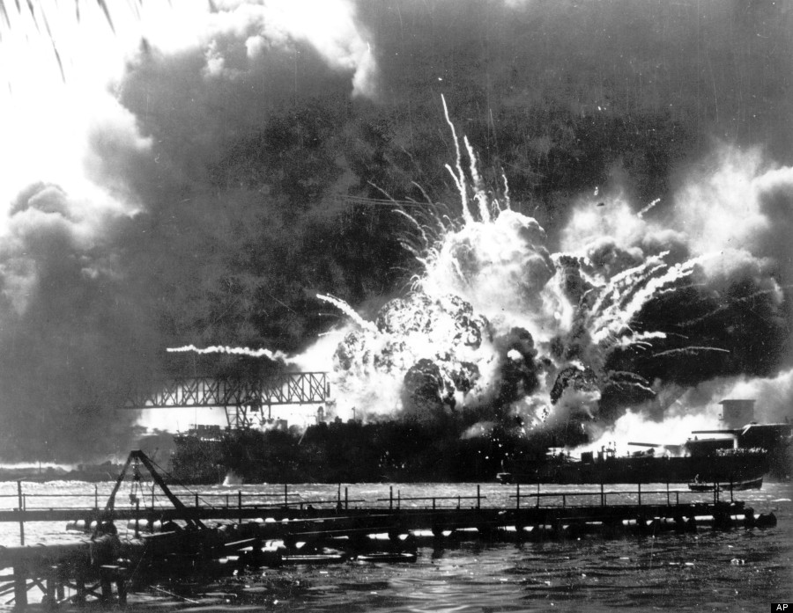
The Japanese had been hoping to catch U.S. aircraft carriers at Pearl Harbor, but the aircraft carriers were out to sea that day. This coincidence was a devastating to the Japanese cause – the destruction of the U.S. aircraft carriers was the key to the success of the larger plan to outlast the U.S. in a larger war.

The next major important naval target was the battleships. On the morning of December 7, 1941, there were eight U.S. battleships at Pearl Harbor, seven of which were lined up at what was called Battleship Row and one (the Pennsylvania) was in dry dock for repairs. (The Colorado, the only other battleship of the U.S.'s Pacific fleet, was not at Pearl Harbor that day.)
Since the Japanese attack was a total surprise, many of the first torpedoes and bombs dropped on the unsuspecting ships hit their targets. The damage done was severe. Although the crews on board each battleship worked feverishly to keep their ship afloat, some were destined to sink.
In addition to the air assault on Battleship Row, the Japanese had launched five midget submarines. These midget subs, which were approximately 78 1/2 feet long and 6 feet wide and held only a two man crew, were to sneak into Pearl Harbor and aid in the attack against the battleships. However, all five of these midget subs were sunk during the attack on Pearl Harbor.
USS Shaw

The Attack on the Airfields
Attacking the U.S. aircraft on Oahu was an essential component of the Japanese attack plan. If the Japanese were successful in destroying a large portion of the U.S. airplanes, then they could proceed unhindered in the skies above Pearl Harbor. Plus, a counter-attack against the Japanese attack force would be much more unlikely.
Thus, a portion of the first wave of Japanese planes that arrived over Pearl Harbor at 7:55 a.m. were ordered to target the airfields that surrounded Pearl Harbor. As the Japanese planes reached the airfields, they found many of the American fighter planes lined up along the airstrips, wingtip to wingtip, making easy targets. The Japanese strafed and bombed the planes, hangers, and other buildings located near the airfields, including dormitories and mess halls.
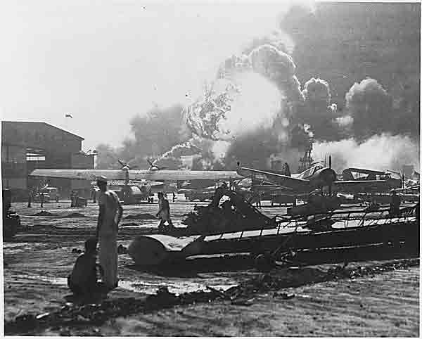
By the time the U.S. military personnel at the airfields realized what was happening, there was little they could do. The Japanese were extremely successful at destroying most of the U.S. aircraft. A few individuals picked up guns and shot at the invading planes.
A handful of U.S. fighter pilots were able to get their planes off the ground, only to find themselves vastly outnumbered in the air. Still, they were able to shoot down a few Japanese planes.
USS Arizona burning
The Attack on Pearl Harbor Is Over
By 9:45 a.m., just under two hours after the attack had begun, the Japanese planes left Pearl Harbor and headed back to their aircraft carriers. The attack on Pearl Harbor was over. All Japanese planes had returned to their aircraft carriers by 12:14 p.m. and just an hour later, the Japanese attack force began their long journey homeward.
The Damage Done
In just under two hours, the Japanese had sunk four U.S. battleships (Arizona, California, Oklahoma, and West Virginia). The Nevada was beached and the other three battleships at Pearl Harbor received considerable damage. Also damaged were three light cruisers, four destroyers, one minelayer, one target ship, and four auxiliaries. Of the U.S. aircraft, the Japanese managed to destroy 188 and damage an additional 159.
The death toll among Americans was quite high. A total of 2,335 servicemen were killed and 1,143 were wounded. Sixty-eight civilians were also killed and 35 were wounded. Nearly half of the servicemen that were killed were on board the Arizona when it exploded.
All this damage was done by the Japanese, who suffered very few losses themselves -- just 29 aircraft and five midget subs.
The United States Enters World War II
The news of the attack on Pearl Harbor quickly spread throughout the United States. The public was shocked and outraged. They wanted to strike back. It was time to join World War II.
At 12:30 p.m. on the day following the attack on Pearl Harbor, President Franklin D. Roosevelt gave an address to Congress in which he declared that December 7, 1941 was "a date that will live in infamy." At the end of the speech, Roosevelt asked Congress to declare war on Japan. With only one dissenting vote (by Representative Jeannette Rankin from Montana), Congress declared war, officially bringing the United States into World War II. Adapted from The National Archives and History 1900s
Answer the following questions on a separate sheet of paper
Comprehension
1. In your own words, explain why Japan attacked the U.S. at Pearl Harbor.
2. Describe the attack at Pearl Harbor from the Japanese perspective.
3. What were the main military targets of the Japanese at Pearl Harbor?
Analysis
4. Some people think that FDR knew about the attack at Pearl Harbor ahead of time and deliberately did nothing to stop the attack. While most historians discount this as a conspiracy theory, from what you have learned already about WWII, why might that be a logical conclusion to draw?

