U.S. Reaction to the Attack on Pearl Harbor

Fear and war hysteria swept the country in the aftermath of the attack on Pearl Harbor. People feared that the Japanese Imperial forces might attack the West Coast of the United States. There was also a widespread (but false) belief that disloyal Japanese American residents in Hawaii had assisted in the Pearl Harbor bombing.
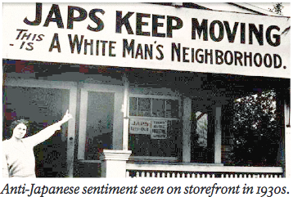
Nowhere did anti-Japanese bigotry run higher than in California and Hawaii, where Japanese-Americans were most heavily concentrated. Unlike German-Americans and Italian-Americans, who numbered in the millions and were spread across the country, there were fewer than a half-million Japanese-Americans. The attack on Pearl Harbor led to fears that Japan was preparing a full-scale attack on the U.S. west coast, making Japanese-Americans -- particularly the American-born, second-generation nisei -- a convenient target for discrimination.
Japan's rapid military conquest of much of Asia made their war machine appear to some Americans frighteningly unstoppable. Civilian and military officials had concerns about the loyalty of Japanese-Americans. Reacting to public pressure, California Governor Culbert L. Olson and Attorney General (later Chief Justice of the U.S. Supreme Court) Earl Warren argued that Japanese Americans were a security risk and that those who were loyal could not be distinguished from those who were disloyal.

The U.S. media would often make no distinction between Japanese Americans and Japanese Imperial soldiers. One Los Angeles Times editorial noted:
A viper is nonetheless a viper wherever the egg is hatched.... So, a Japanese American born of Japanese parents, nurtured upon Japanese traditions, living in a transplanted Japanese atmosphere and thoroughly inoculated with Japanese ...ideals, notwithstanding his nominal brand of accidental citizenship almost inevitably and with the rarest exceptions grows up to be a Japanese, and not an American....
Furthermore, by applying the dehumanizing term "Jap" to any ethnically Japanese person, the front pages of daily newspapers blurred the distinction between Japanese Americans and Japanese Imperial troops. For instance, one edition of the San Francisco Examiner, published around the time of forced removal, declared in a boldfaced headline, "OUSTER OF ALL JAPS IN CALIFORNIA NEAR!" That same front page contained an article on the battles that were being waged in Indonesia. The title of the latter article read "Thousands of Allies Face Japs in Java." Representations such as these perpetuated public confusion and the spread of misinformation.
Upon examination of historical record, however, it became clear that these concerns often grew more out of anti-Asian racial hatred than any actual security risk, particularly since no such alarm was raised about German-Americans and Italian-Americans.
By dehumanizing the Japanese and instilling fear in the minds of Americans, WWII propaganda posters prompted cultural and racial hatred that led to massive historical consequences for the Japanese. Among the more common characterizations of the Japanese was the idea that they were “uncivilized”—ugly, notorious, villainous, and savage.
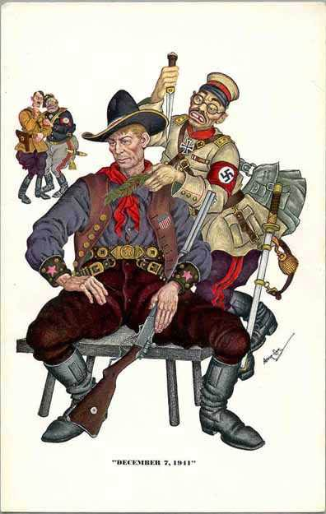
Below, one illustrator called upon the romanticized idea of the United States as a rough but honest “cowboy” who was stabbed in the back by Japan. Here Japan is depicted in Nazi Germany dress, yet the character still retains distortedly gruesome facial features. The Nazi dress on the Japanese character suggests that the Japanese were mindless puppets controlled by Germany.
This hatred was one of the factors that led to inhumane treatment of the Japanese, even on American soil.
Over 100,000 Japanese Americans were confined to internment camps – Japanese Americans living on the Pacific Coast were forced to relocate to prison camps for the duration of the war. This confinement led to the loss of Japanese property, the separation of families, and numerous deaths due to the conditions of the camps. Although the war was being fought against the Japanese overseas, Japanese Americans were ultimately mistrusted and mistreated by the members of the dominant American culture.
Answer the following 4 questions on a separate sheet of paper:
Comprehension
1. What was Americans’ (civilians, not the gov’t) response to the Pearl Harbor attack, specifically in relation to the Japanese and Japanese Americans? Explain and give examples.
2. What was the government’s reaction to the anti-Japanese sentiment? In other words, what happened to Japanese-Americans during the war?
Interpretation
3. How were the feelings about Japanese-Americans different from how Americans felt about German-Americans and Italian-Americans? Explain.
Opinion
4. Do you think the internment of Japanese-Americans during WWII justified? Why or why not?

Adapted from:
National Park Service: Patriotism and Prejudice, Japanese Americans and World War II
George Mason University: Open Season, Anti-Japanese Propaganda During WWII
University of Missouri: Artifacts Journal, WWII Propaganda and the Influence of Racism

