MATHEMATICS SAT FAQ

Q: What SAT Mathematics tests are there?
A: The SAT test includes Mathematics, Reading, and Writing. The Mathematics SAT subject tests are called the “Mathematics Level 1 and Level 2 Subject Tests” (formerly known as “Mathematics IC & IIC” and before that as “Mathematics Achievement Tests”).

Q: Which level Math subject test should I take?
A: CCHS Honors Pre-Calculus students are prepared to take the Level 2 test.
CCHS CP1 & CP2 Pre-Calculus students are prepared to take the Level 1 test.
(While CP1 Students will have a strong background for Level 1, they haven't covered certain topics that are on the Level 2 test)

Q: When should I take the test?
A: Juniors take the regular SAT test (including the Mathematics portion) in March or May.
Juniors taking Pre-Calculus take the SAT Level 1 or Level 2 Math Subject Test in June and can retake it as Seniors in October, November, or December

Q: What are the topics tested on the SAT tests?
A: Level 1:

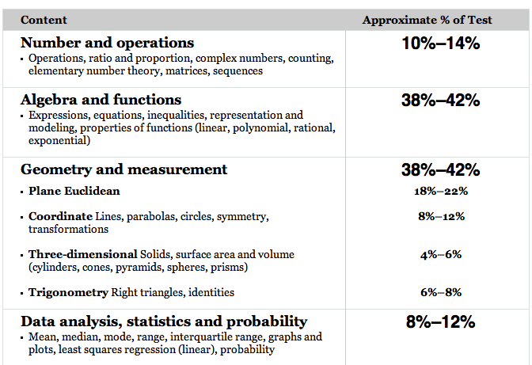
A: Level 2:
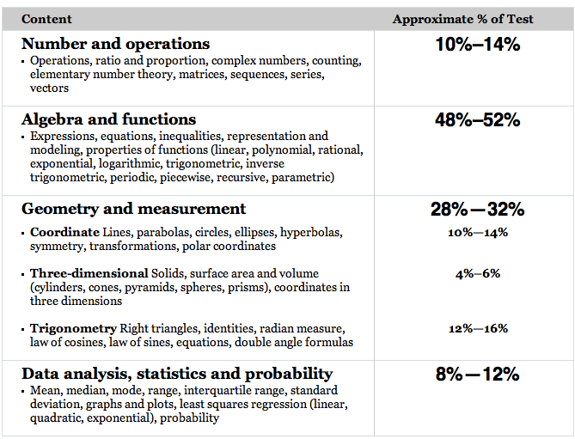

A: Regular SAT Mathematics:
Number and operations questions (~25%)
- Arithmetic word problems (including percent, ratio, and proportion)
- Properties of integers (even, odd, prime numbers, divisibility, and so forth)
- Rational numbers
- Sets (union, intersection, elements)
- Counting techniques
- Sequences and series (including exponential growth)
- Elementary number theory
Algebra and functions questions (~40%)
- Substitution and simplifying algebraic expressions
- Properties of exponents
- Algebraic word problems
- Solutions of linear equations and inequalities
- Systems of equations and inequalities
- Quadratic equations
- Rational and radical equations
- Equations of lines
- Absolute value
- Direct and inverse variation
- Concepts of algebraic functions
- Newly defined symbols based on commonly used operations
Geometry and measurement questions (~25%)
- Area and perimeter of a polygon
- Area and circumference of a circle
- Volume of a box, cube, and cylinder
- Pythagorean theorem and special properties of isosceles, equilateral, and right triangles
- Properties of parallel and perpendicular lines
- Coordinate geometry
- Geometric visualization
- Slope
- Similarity
- Transformations
Data analysis, statistics, and probability questions (~10%)
- Data interpretation (tables and graphs)
- Descriptive statistics (mean, median, and mode)
- Probability

